🧪 🚀 LAB: Advanced Shell Scripting Techniques
Now we move from:
👉 “basic scripting”
to:
🔥 “real DevOps-style scripting”
This lab teaches:
✅ Functions
✅ Arguments
✅ Loops
✅ Error handling
✅ Logging
✅ System monitoring

🎯 Scenario
Create a script that:
- Checks CPU, memory, disk
- Logs output
- Handles errors
- Uses functions
- Accepts user arguments

⚙️ Step 1: Create script
nano advanced.sh

✍️ Step 2: Paste FULL script
#!/bin/bash
LOGFILE="system_health.log"
# =========================
# Function: Log Message
# =========================
log_message() {
echo "$(date) : $1" >> $LOGFILE
}
# =========================
# Function: CPU Check
# =========================
check_cpu() {
cpu=$(top -bn1 | grep "Cpu" | awk '{print $2}')
echo "🔥 CPU Usage: $cpu%"
log_message "CPU Usage: $cpu%"
}
# =========================
# Function: Memory Check
# =========================
check_memory() {
memory=$(free -m | awk '/Mem:/ {print $3}')
echo "🧠 Memory Used: ${memory}MB"
log_message "Memory Used: ${memory}MB"
}
# =========================
# Function: Disk Check
# =========================
check_disk() {
disk=$(df -h / | awk 'NR==2 {print $5}')
echo "💽 Disk Usage: $disk"
log_message "Disk Usage: $disk"
}
# =========================
# Error Handling
# =========================
handle_error() {
echo "❌ Error occurred!"
log_message "ERROR detected"
}
trap handle_error ERR
# =========================
# Main Script
# =========================
echo "🚀 Advanced Monitoring Script Started"
log_message "Script started"
# Loop through checks
for check in cpu memory disk
do
case $check in
cpu)
check_cpu
;;
memory)
check_memory
;;
disk)
check_disk
;;
esac
sleep 2
done
echo "✅ Monitoring Completed"
log_message "Script completed"
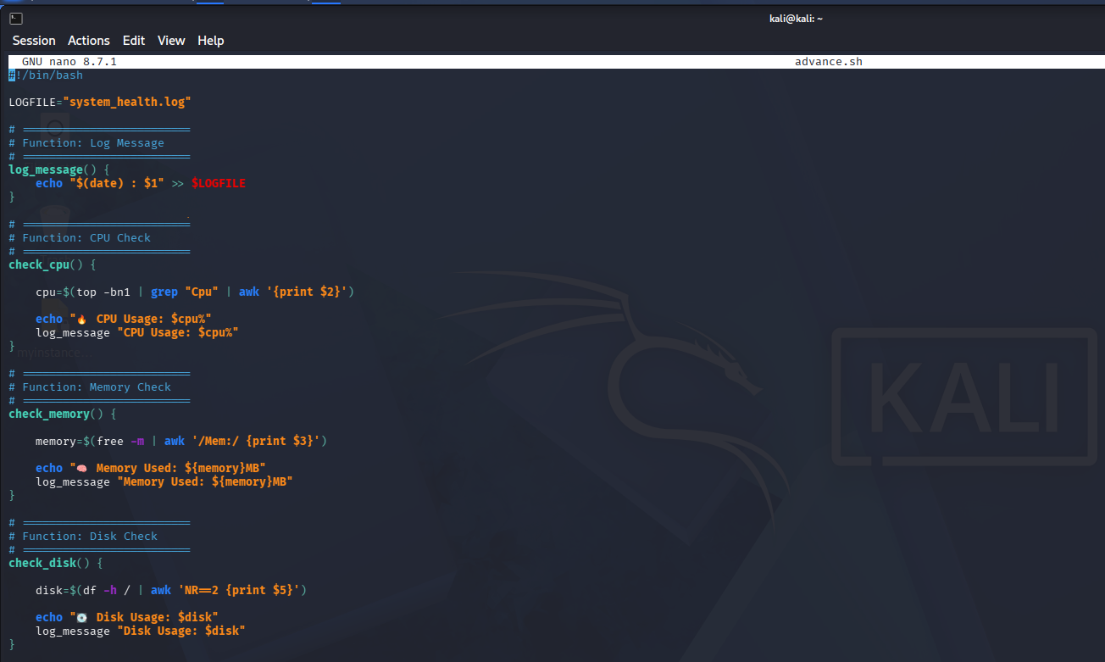
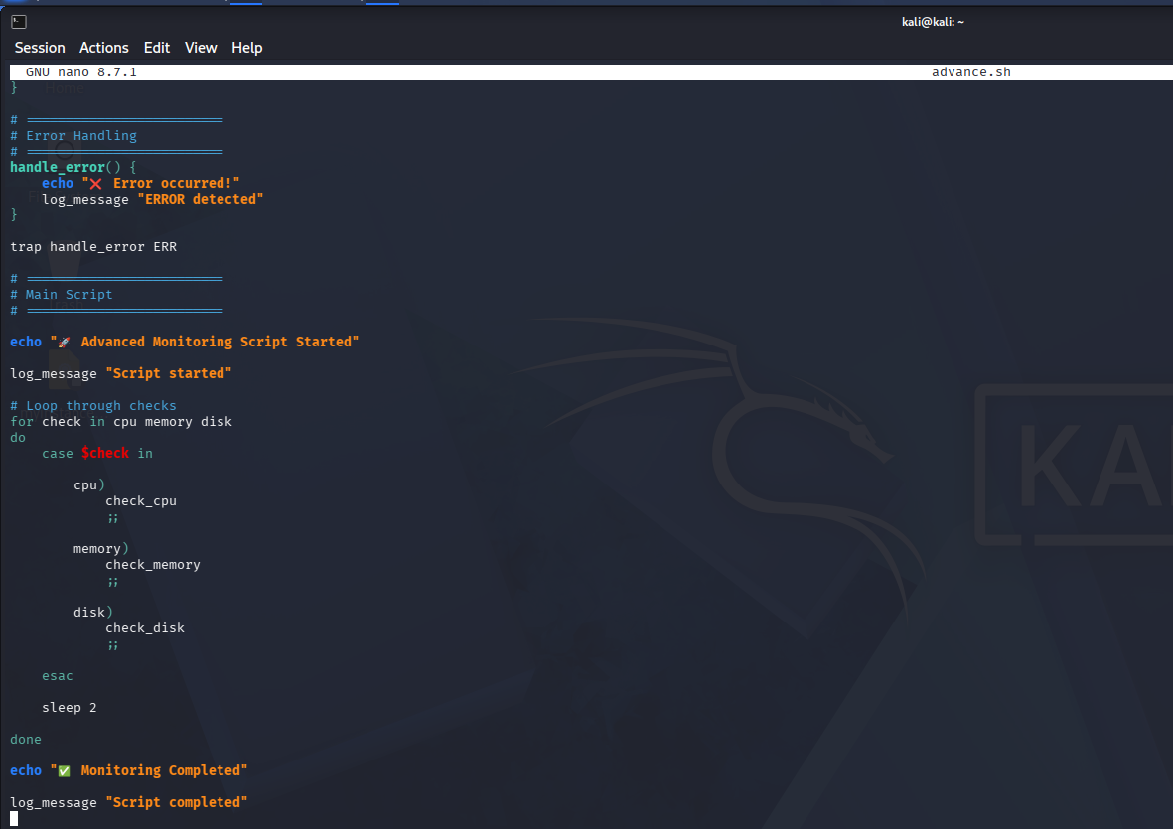

🔐 Step 3: Give permission
chmod +x advanced.sh

▶️ Step 4: Run script
./advanced.sh

🎯 Expected Output
🚀 Advanced Monitoring Script Started
🔥 CPU Usage: 5.3%
🧠 Memory Used: 1200MB
💽 Disk Usage: 42%
✅ Monitoring Completed
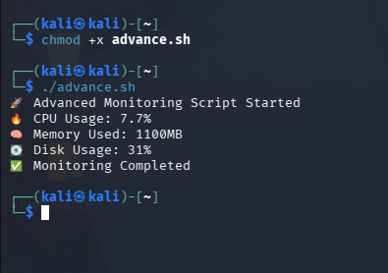

📂 Step 5: View log file
cat system_health.log
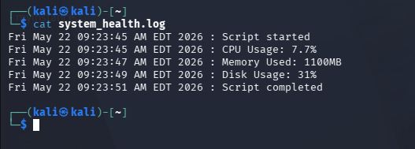

🧠 Advanced Concepts Used
Technique | Purpose
Functions | Reusable code
Variables | Store values
case | Multiple conditions
trap | Error handling
awk | Data extraction
Logging | Save output
Loop | Automation

🔥 Step 6: Simulate error
Add this line inside script:
wrongcommand
👉 Script triggers:
❌ Error occurred!

🎤 Interview-ready explanation
“I created an advanced Bash monitoring script using functions, loops, logging, case statements, and trap-based error handling to monitor CPU, memory, and disk usage.”

🚀 Real-world DevOps usage
This type of scripting is used in:
- Server health monitoring
- Automation jobs
- Incident detection
- CI/CD pipelines
- Infrastructure monitoring

💡 Mini Challenge
Modify script to:
✅ Check service status
✅ Alert if disk > 80%
✅ Save alerts separately

